**File: Lubomir_Yankov_16_650c0b.rb**

Task:

Develop a program named FirstName_LastName_ClassNumber_650c0b.rb

1. you are given two arguments for a folders with files;

1.1 if there are other arguments they should be discarded;

2. Find all the files from both folders that have exactly 7 digits from 0 to 9 in their names excluding extension. If there are duplicates the file must be written only once.;

3. Calculate the length of their names (including extensions) divided by 2 rounded to the smalles number;

4. Sort the result by File name ;

5. Produce a result in CSV format named result.csv:

File1,3

File2,4

...

FileN,3

Code:

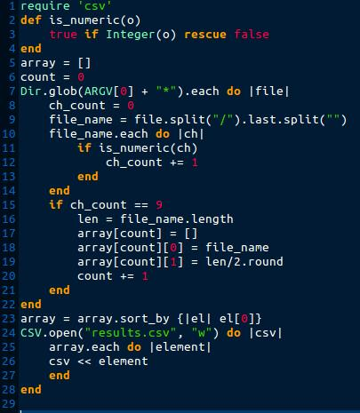

Errors:

* Program use only the first argument
* Check for file format - missing
* Program will write duplicates files several time
* Loop in line 10 up to 14 does not work properly
* Wrong named CSV file

New code:

